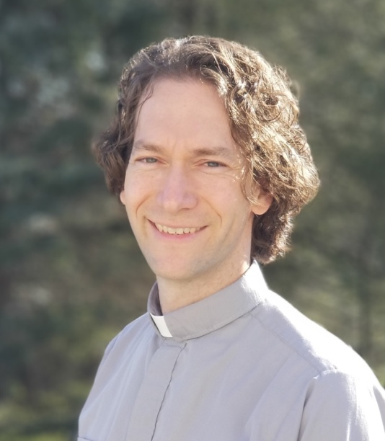
Rev. Joseph A. Motz holds a deep passion for people, the church, and the communities he is called to serve. His experience spans over 20 years of summer camp ministry, state park chaplaincy, and congregational ministry. In 2020, he was awarded the Lancaster Theological Seminary’s Meck Award for distinguished service in the practice of pastoral ministry for his work of uniting churches, businesses, non-profits, and local government to serve the physical and spiritual needs of his congregation’s wider community through a newly created ministry called “Mission Trip Birdsboro.”
Rev. Motz brings a creative and collaborative approach to ministry that seeks to build off the strengths of congregations and their wider community in order to dynamically live out the Gospel of Christ. His approach to the Christ faith inspires a yearning for discipleship in youth and adults of all ages, a congregational environment that is attractive to the de-churched and unchurched, and a grounding in the power and presence of the Spirit to lead the church in fulfilling its calling.
Rev. Motz earned his Bachelor of Arts in Psychology & Philosophy from Juniata College, during which time he also studied abroad at Aberdeen University in Scotland. He earned his Masters of Divinity from Lancaster Theological Seminary, completed his Clinical Pastoral Education Level 1 at the Reading Hospital, and has engaged in foundational training for Gestalt Pastoral Care. Currently he is enrolled in an International Coaching Federation certified coach training program to become a Professional Certified Coach in order to enhance his capacity for leadership development and congregational vitality.
Within the United Church of Christ, Rev. Motz guided the merger of the Reading, Heidelberg, and East Berks Associations into the unified Covenant Association. Following the merger, as President of the newly formed Covenant Association he helped provide the oversight, accountability, and support needed for the Association to begin growing into the vision for which it was created.
Beyond the church, Rev. Motz is dedicated to his family, which includes Jessica (his wife of seventeen years), his three daughters (Natalie - 14, Olivia - 12, Caitlyn - 7), and his extended family. In his free time, he enjoys biking, running, backpacking, spending time in nature, gardening in his backyard, and joining in where-ever there is a good game or conversation to be had with friends and family.
Pastor Joe will begin his ministry with Bausman Memorial UCC on August 15, 2022.

